|  |  |
| --- | --- |
| Name : [Jonell](mailto:johnvincentdallego082193@gmail.com) Jefferson C. Fial II | Section : BSIT 3A |
| Assignment No : 2 | Submission Date : March 23, 2024 |
| Assignment Title: Rock Paper Scissors | |

**Code :HTML FILE**

*<!DOCTYPE html>*

*<html lang="en">*

*<head>*

*<meta charset="UTF-8">*

*<meta name="viewport" content="width=device-width, initial-scale=1.0">*

*<title>Rock Paper Scissors</title>*

*<link rel="stylesheet" href="style.css">*

*</head>*

*<body>*

*<h1>BATO BATO PIC</h1>*

*<div id="resultDisplay"> </div>*

*<br>*

*<div class="score">*

*<h2>Scoreboard</h2>*

*<table>*

*<tbody>*

*<tr>*

*<td class="scoreDisplay"><span id="playerScoreDisplay">0</span></td>*

*</div>*

*<td class="scoreDisplay"><span id="computerScoreDisplay">0</span></td>*

*</div>*

*</tr>*

*</tbody>*

*<tfoot>*

*<tr>*

*<th>You <div id="playerDisplay"></div></th>*

*<th>AI <div id="computerDisplay"> </div></th>*

*</tr>*

*</tfoot>*

*</table>*

*</div>*

*<br>*

*<br>*

*<div id="choices">*

*<button onclick="playgame('rock')">👊</button>*

*<button onclick="playgame('paper')">🤚</button>*

*<button onclick="playgame('scissors')">✌️</button>*

*</div>*

*<br>*

*<button class="reset" onclick="resetGame()">Reset Game</button>*

*<script src="script.js"></script>*

*</body>*

*</html>*

**JS FILE**

*const choices = ["rock", "paper", "scissors"];*

*const playerDisplay = document.getElementById("playerDisplay");*

*const computerDisplay = document.getElementById("computerDisplay");*

*const resultDisplay = document.getElementById("resultDisplay");*

*const computerScoreDisplay = document.getElementById("computerScoreDisplay");*

*const playerScoreDisplay = document.getElementById("playerScoreDisplay");*

*let playerScore = 0;*

*let computerScore = 0;*

*function playgame(playerChoice) {*

*const computerChoice = choices[Math.floor(Math.random() * 3)];*

*let result = "";*

*if (playerChoice === computerChoice) {*

*result = "TIE!";*

*} else {*

*switch (playerChoice) {*

*case "rock":*

*result = (computerChoice === "scissors") ? "YOU WIN!" : "YOU LOSE!";*

*break;*

*case "paper":*

*result = (computerChoice === "rock") ? "YOU WIN!" : "YOU LOSE!";*

*break;*

*case "scissors":*

*result = (computerChoice === "paper") ? "YOU WIN!" : "YOU LOSE!";*

*break;*

*}*

*}*

*playerDisplay.textContent = ` ${playerChoice}`;*

*computerDisplay.textContent = ` ${computerChoice}`;*

*resultDisplay.textContent = result;*

*resultDisplay.classList.remove("win", "lose");*

*switch(result){*

*case "YOU WIN!":*

*resultDisplay.classList.add("win");*

*playerScore++;*

*playerScoreDisplay.textContent = playerScore;*

*break;*

*case "YOU LOSE!":*

*resultDisplay.classList.add("lose");*

*computerScore++;*

*computerScoreDisplay.textContent = computerScore;*

*break;*

*case "TIE!":*

*resultDisplay.classList.add("tie");*

*break;*

*}*

*}*

*function resetGame() {*

*playerScore = 0;*

*computerScore = 0;*

*playerScoreDisplay.textContent = playerScore;*

*computerScoreDisplay.textContent = computerScore;*

*resultDisplay.textContent = "";*

*}*

**CSS FILE**

*body {*

*font-family:'Gill Sans', 'Gill Sans MT', Calibri, 'Trebuchet MS', sans-serif;*

*margin: 0;*

*display: flex;*

*flex-direction: column;*

*align-items: center;*

*}*

*h1 {*

*font-size: 3.5rem;*

*color: black;*

*}*

*.choices {*

*margin-bottom: 30px;*

*justify-content: center;*

*}*

*#choices button {*

*font-size: 2.5rem;*

*height: 90px;*

*width: 90px;*

*margin: 0 10px;*

*border-radius: 50%;*

*background-color: rgb(131, 131, 3);*

*cursor: pointer;*

*transition: background-color 0.5s ease;*

*}*

*#choices button:hover {*

*background-color: rgb(0, 221, 221);*

*}*

*.reset{*

*border-radius: 20px;*

*border: none;*

*cursor: pointer;*

*height: 50px;*

*width: 100px;*

*background-color: rgb(131, 131, 3);*

*color: white;*

*font-weight: bolder;*

*}*

*.win, #playerScoreDisplay {*

*color: rgb(24, 179, 24);*

*}*

*.lose, #computerScoreDisplay {*

*color: rgb(235, 12, 12);*

*}*

*#resultDisplay{*

*font-size: 30px;*

*}*

*.score{*

*box-shadow: 0px 0px 19px 1px #e8dede;*

*width: 30em;*

*margin: auto;*

*border: 1px solid rgb(0, 0, 0);*

*}*

*.score h2 {*

*border-bottom: 1px solid rgb(0, 0, 0);*

*margin: 0;*

*padding: 10px;*

*text-align: center;*

*}*

*.score table {*

*margin: 10px auto;*

*width: 100%;*

*border-collapse: collapse;*

*}*

*.score th, .score td {*

*text-align: center;*

*}*

*.score td {*

*font-size: 3em;*

*padding: 0 20px;*

*}*

**SCREENSHOT**

*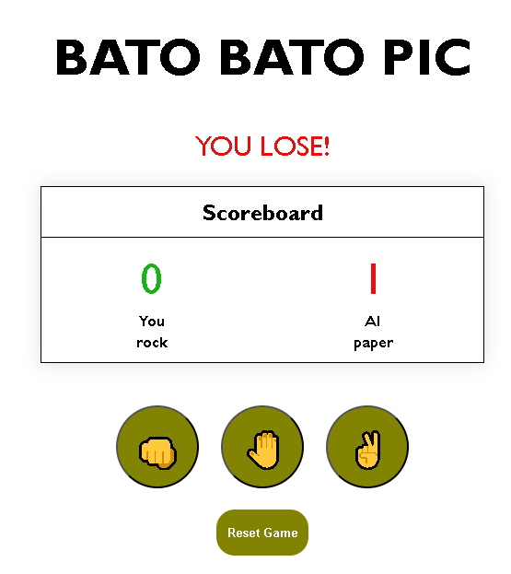***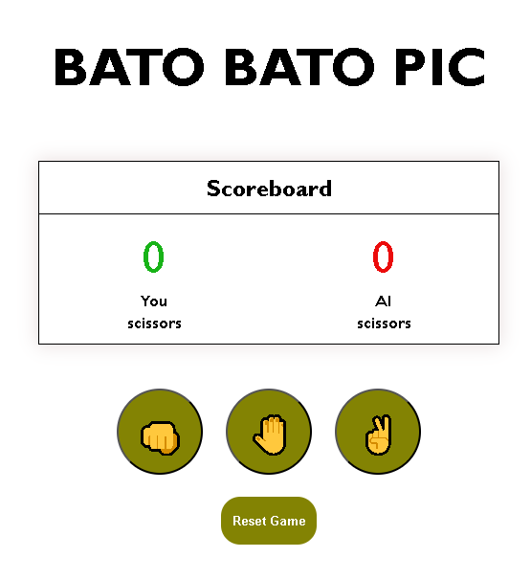**

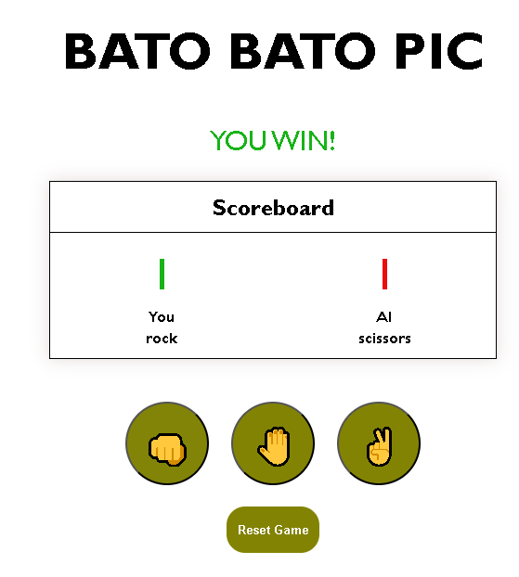

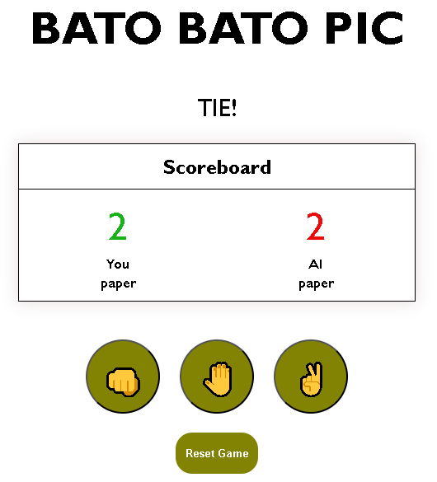

**Dictionary:**

* **Math.random** – returns a random float number

**Syntax**: Math.random() **Parameters:** none

This command was used to generate a random number which will be used as the computer’s choice

* **Math.floor** – rounds a number down

**Syntax:** math.floor(x)

**Parameter:** x (number to round down)

This command was used to round down the generated random number

* **resetGame() -** This function resets the game by setting both the player's and the computer's scores to zero and clearing the result display.

**Syntax**: resetGame()

**Parameters:** None. This function doesn't accept any parameters.

* **playerScore++, computerScore++**

These statements increment the score of either the player or the computer by one.

**Syntax:** playerScore++; computerScore++;

**Parameters:** None.

These statements increment the values of the playerScore and computerScore variables by one.

* **classList.add("className"), classList.remove("className")**

These methods are used to add or remove a CSS class from an HTML element's class list, allowing dynamic styling changes.

**Syntax:**

element.classList.add("className");

element.classList.remove("className");

**Parameters:** "className"

is the name of the CSS class you want to add or remove. element is the HTML element object whose class list you want to manipulate.